Handout no.12

|  |  |
| --- | --- |
| **Name** | MUHAMMAD AHMAD, ASAD, FAIZAN |
| **Reg. No** | 2019-EE-373, 381, 383 |
| **Marks/Grade** |  |

# EXPERIMENT NO. 12

**Perform Load frequency control of generator using PI controller.**

**Objective:**

At the end of this lab session, students will be able

➢ To accurately select the parameters of generator elements and PI controller for smooth operation.

**Introduction:**

Load frequency control (LFC) is critical to power system stability. It is responsible for maintaining the balance between load and generation in real time by regulating the power system’s frequency. A proportional-integral (PI) controller is a commonly used method for LFC. The PI controller measures the frequency deviation from the nominal frequency and then adjusts the generator's output power accordingly. The proportional term provides an immediate response to frequency deviations, while the integral term corrects any steady-state errors. The PI controller's gains can be tuned to achieve the desired system response. However, the gains must be chosen carefully to ensure system stability and prevent overshoot or instability. Overall, the use of a PI controller for LFC can ensure power system stability and minimize frequency deviations, ultimately resulting in a more reliable and efficient power system.

**Task 1:**

Figure 12.1: Load frequency control circuit (Simulink)

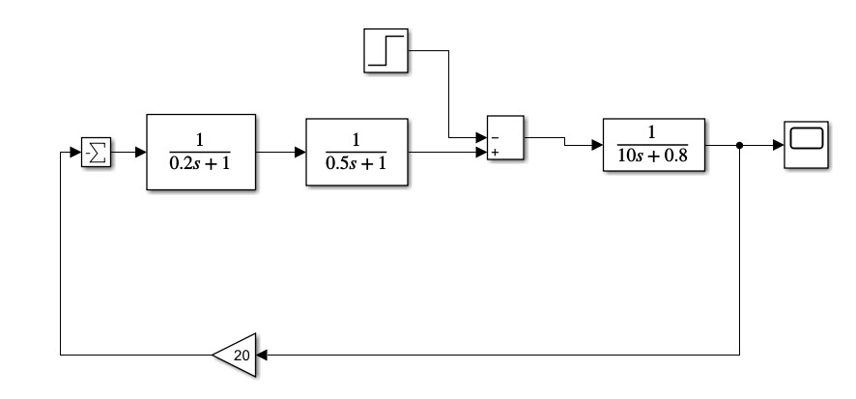

Figure 12.2: Frequency deviation step

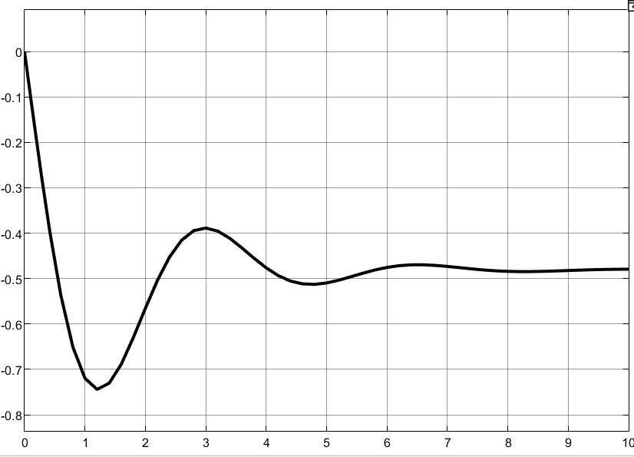

**Task 2:**

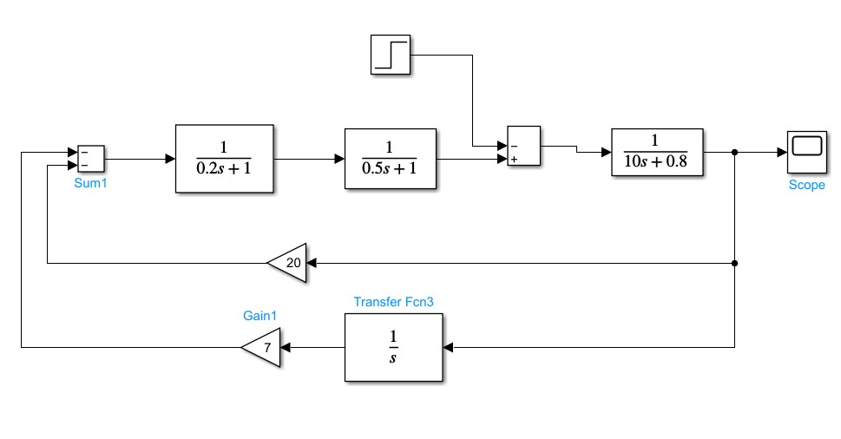

Figure 12.3:Load frequency control with PI controller

Figure 12.4: Frequency deviation step response

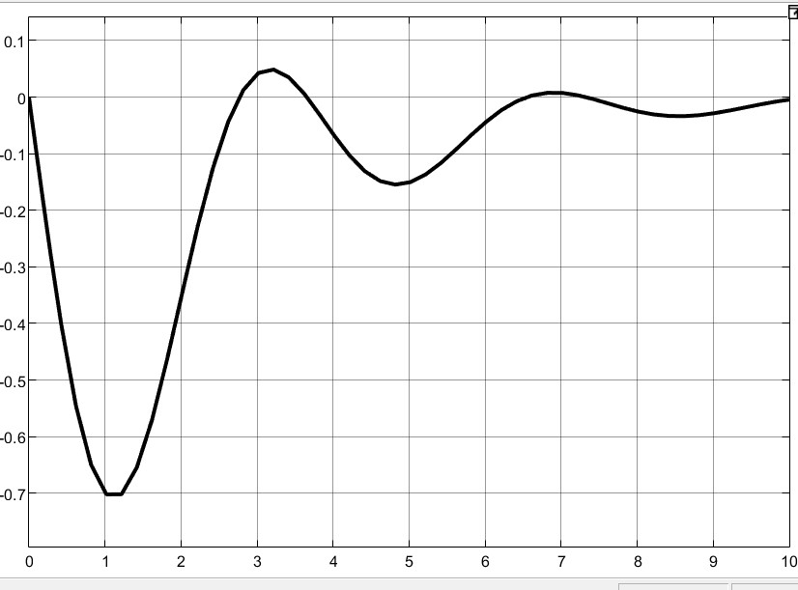

**Task 3:**

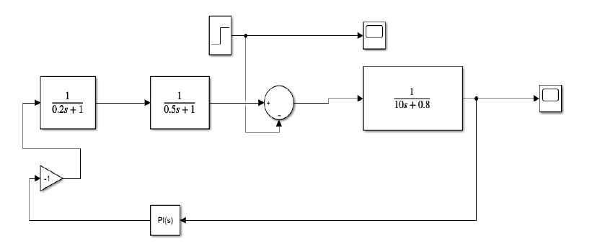

Figure 12.5: Load frequency control circuit with PI controller

Figure 12.6: Frequency deviation step response

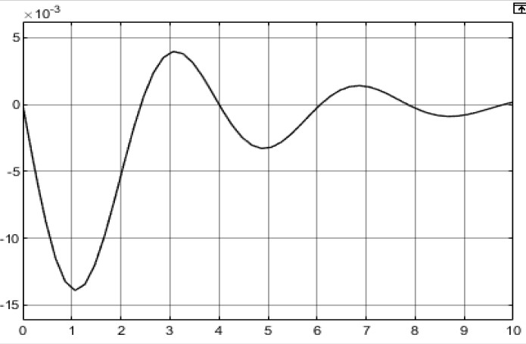

**Conclusion:**

In this lab we have learned about the load frequency control.load frequency control is an important aspects of power system operation that ensures the stability and reliability of the grid. In Power system when the load increase there is a burden on turbine shaft and electrical power become greater than the mechanical power due to which rotor decelerates and release stored kinetic energy resulting in slowing the turbine speed and hence the frequency of the system drops and vice versa with the decrease in load, the frequency increase. To emphasize this effect load frequency control model is built in MATLAB. To restore Frequency when the frequency drops the turbine valve should open and restore frequency. This is done by the PI & PID controller that gives the gain values in proportion to increase or decrease in frequency and correspondingly gives a signal to the turbine valve to increase or decrease the flow of steam on the turbine.

Overall, load frequency control using PI controller is a well- establish technique that has been widely used in power system. Its effectiveness has been demonstrated through both simulation studies and real-sword applications.